Sonny Desai

**HW #4**

A)

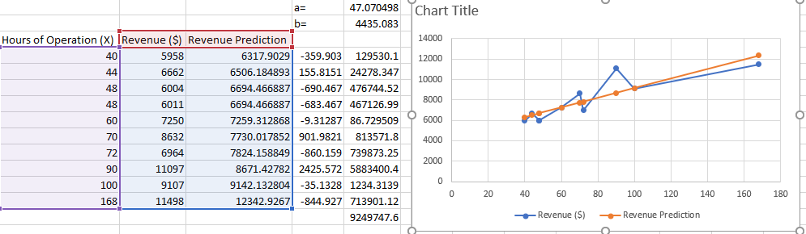

y = 47.0705x + 4435.08

x=120, revenue is 10,083.50

b)

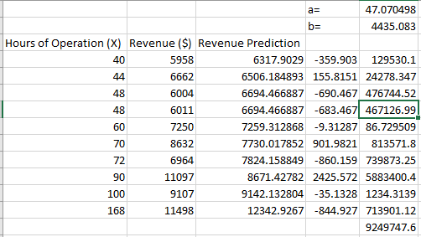

There is no need to develop further constraints because our sum of squares model solves the problem. However, a quadratic fit might be more accurate

2)

a)

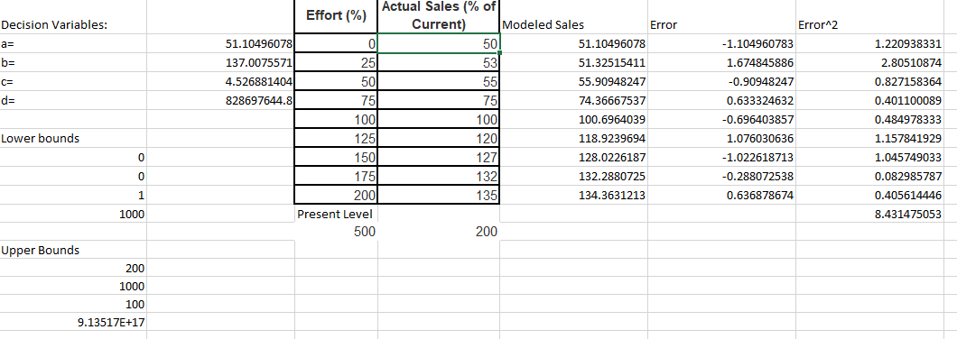

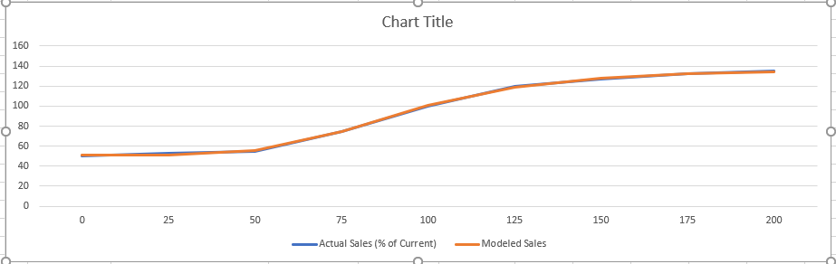

b) S = 61.84844

3)

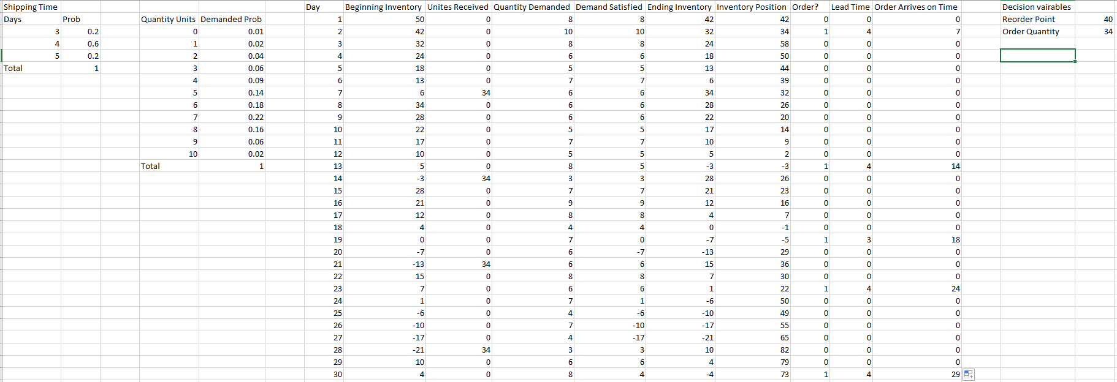

Reorder point 41, order quantity of 29 provides monthly maximum profit.

4)

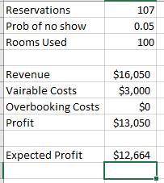

5)

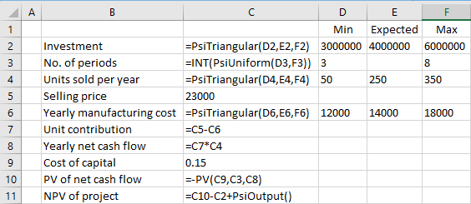

Expected Npv would be the mean value as per the graph i.e. 1586660.82 dollars.

﻿There 27.8% chance that the NPV will be less than zero. And the rest 72.2% chance that it will generate a positive NPV.